HANS RAJ MAHILA MAHA VIDYALAYA, JALANDHAR
WELFARE MEASURES FOR TEACHING/NON-TEACHING STAFF

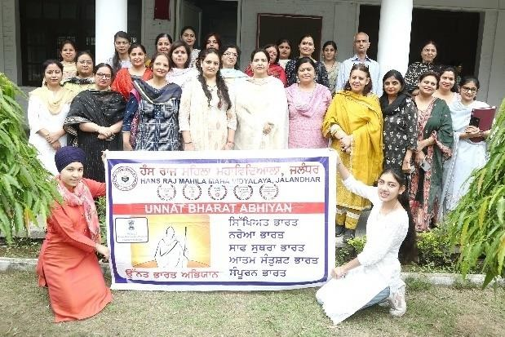

A workshop on “Diet and Ayurveda” was organized on 04-05-2024. The Resource Person was Dr. Nishu Raina, Deputy Medical Superintendent, Associate Prof. Kayachakre, Dayanand Ayurvedic College, Jalandhar.
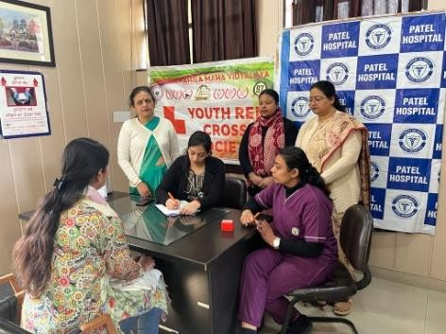

Health Check up Camp was organized on 02-04-2024, Gynecologist from Patel Hospital Dr. Pooja Kiran did the Check ups.
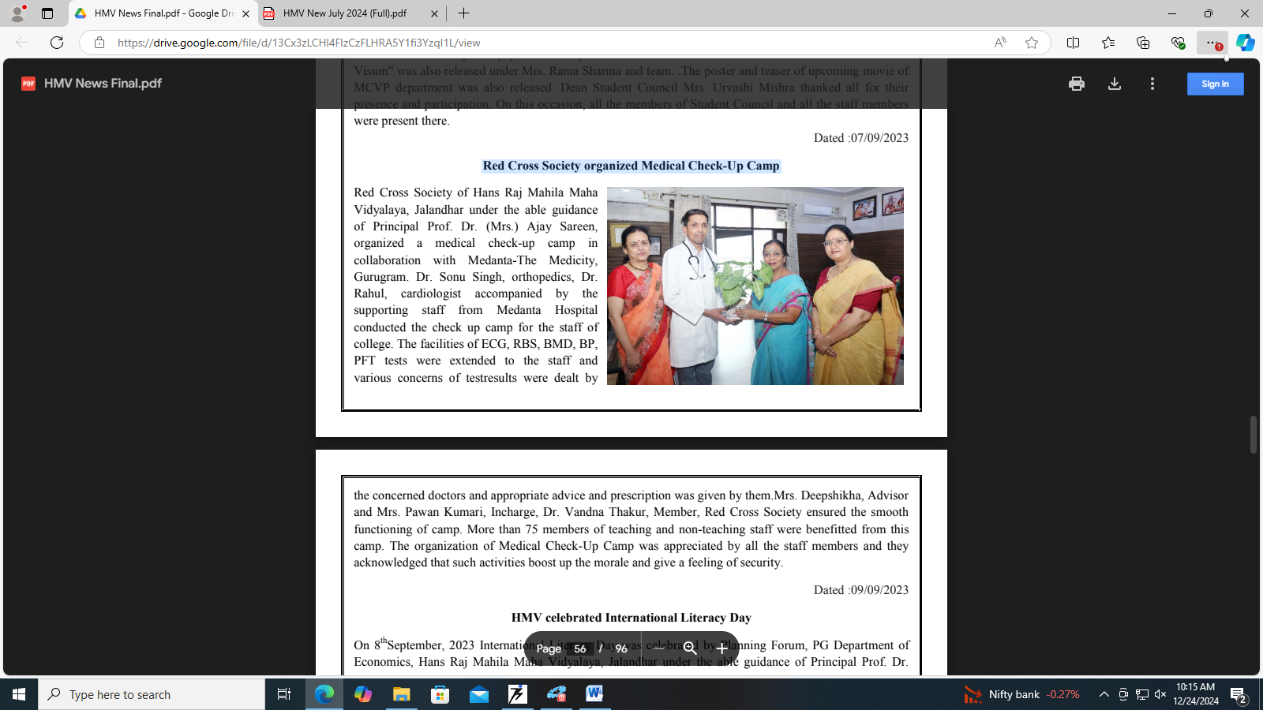
A medical check-up camp in collaboration with Medanta-The Medicity, Gurugram was organized on 09/09/2023.

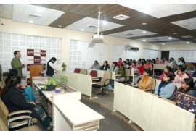
A Seminar on “Cancer Awareness” was organized on the occasion of Cancer Day on 11-02-2024. The Resource Person of the Seminar was Dr. Naveen Nanda, senior Consultant Radition Oncology.

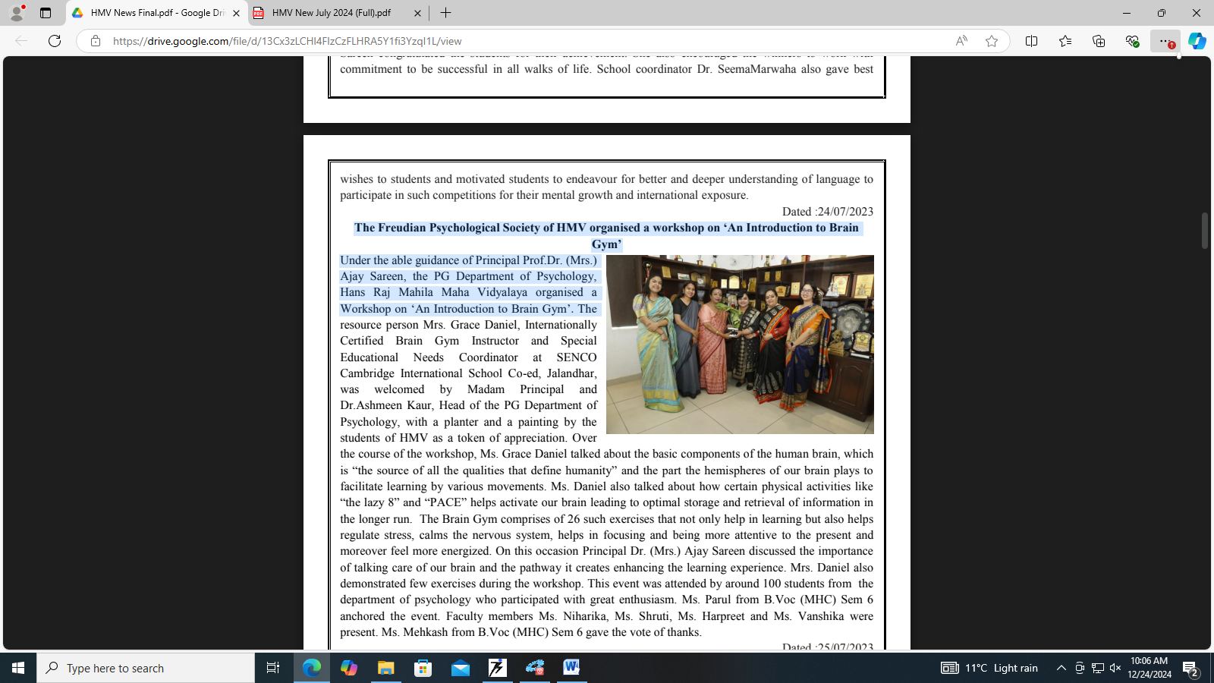
A workshop was organized on the topic “An Introduction to Brain Gym” by The Freudian Psychological Society of HMV on 25-7-2023.
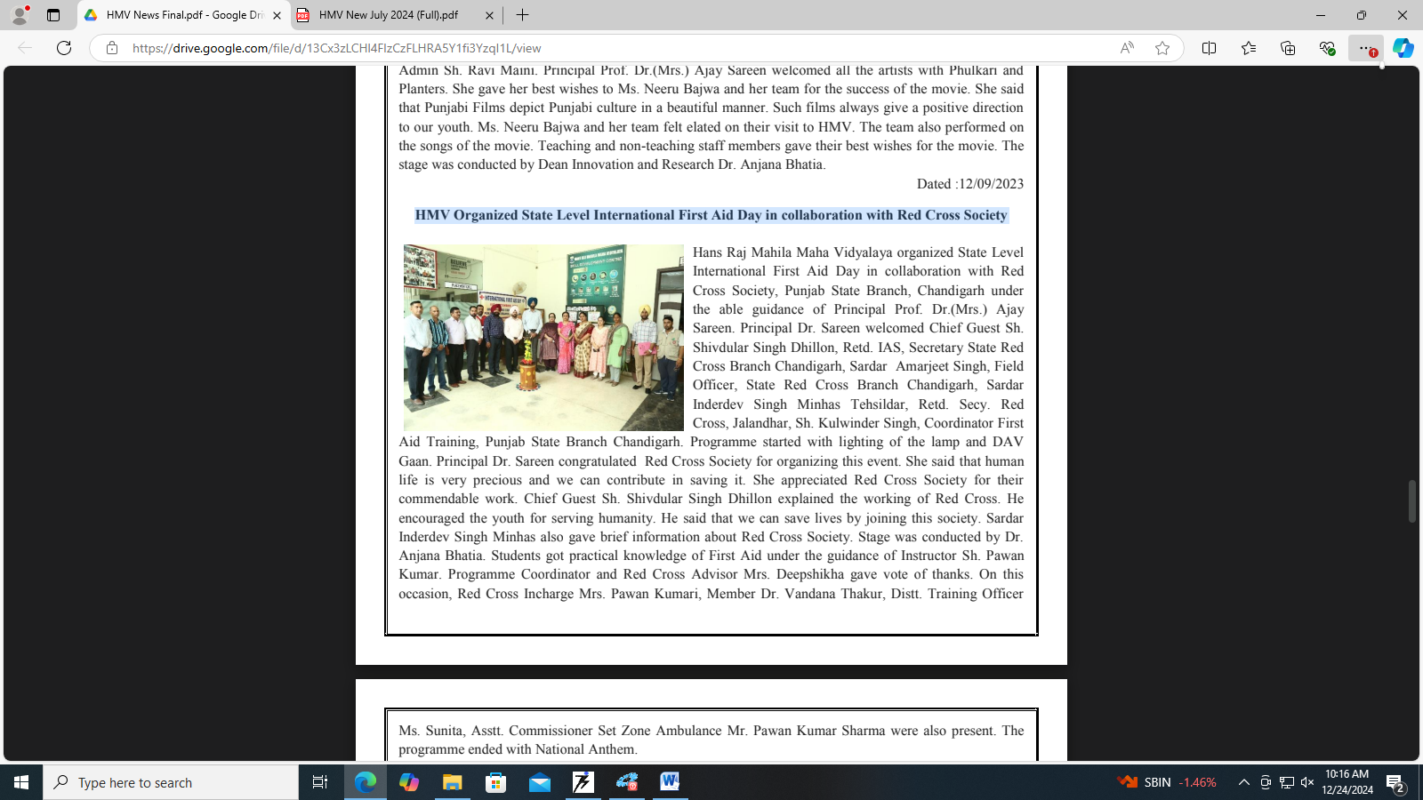

State Level International First Aid Day in collaboration with Red Cross Society on 18/10/2023.

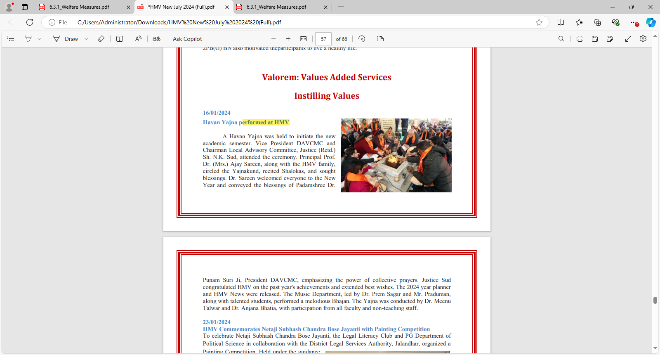
Havan Yajna is performed on the first day of every month.

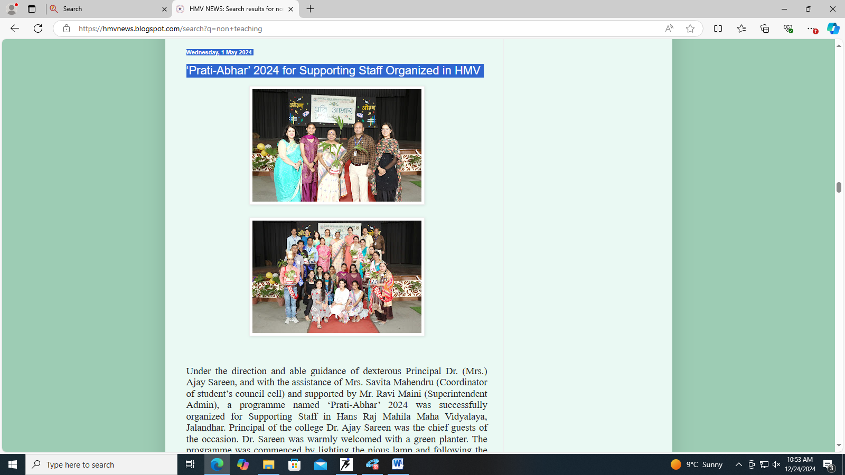

Prati Abhaar, a get-together to recognize the services of supporting staff, is organized by the Institution.
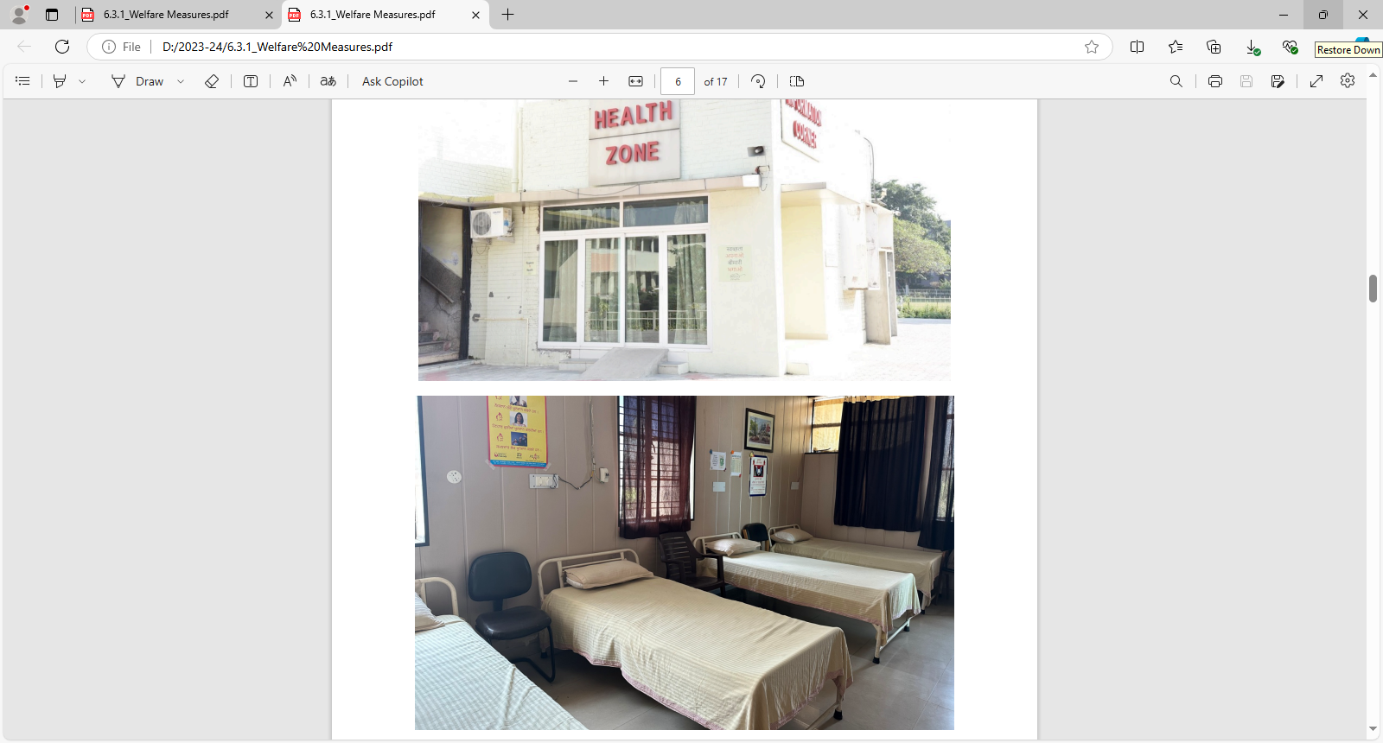
Health Centre and medical facility with a qualified doctor available during working hours.
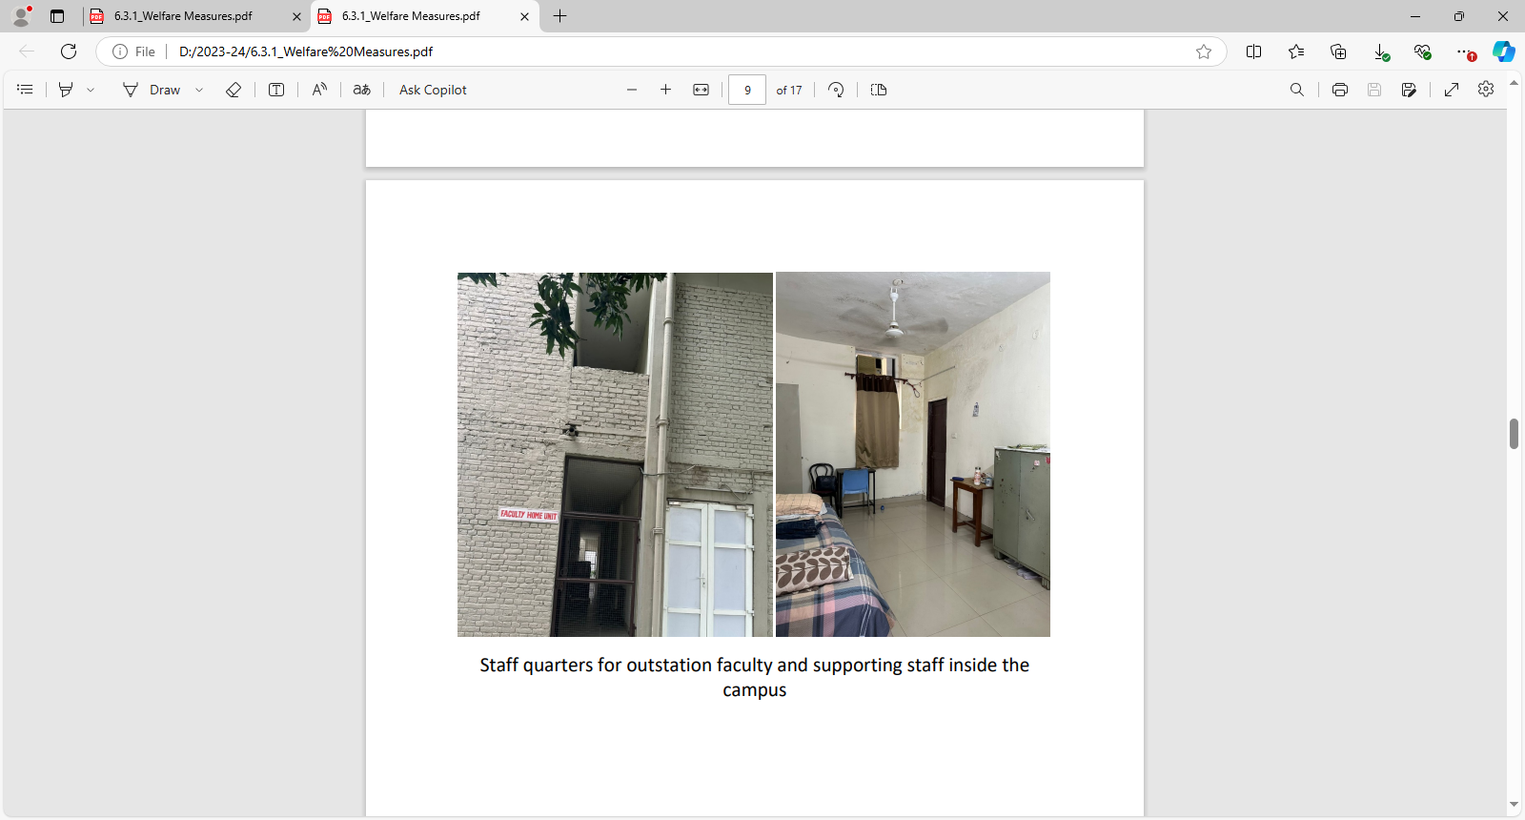
Staff quarters for outstation faculty and supporting staff inside the campus.
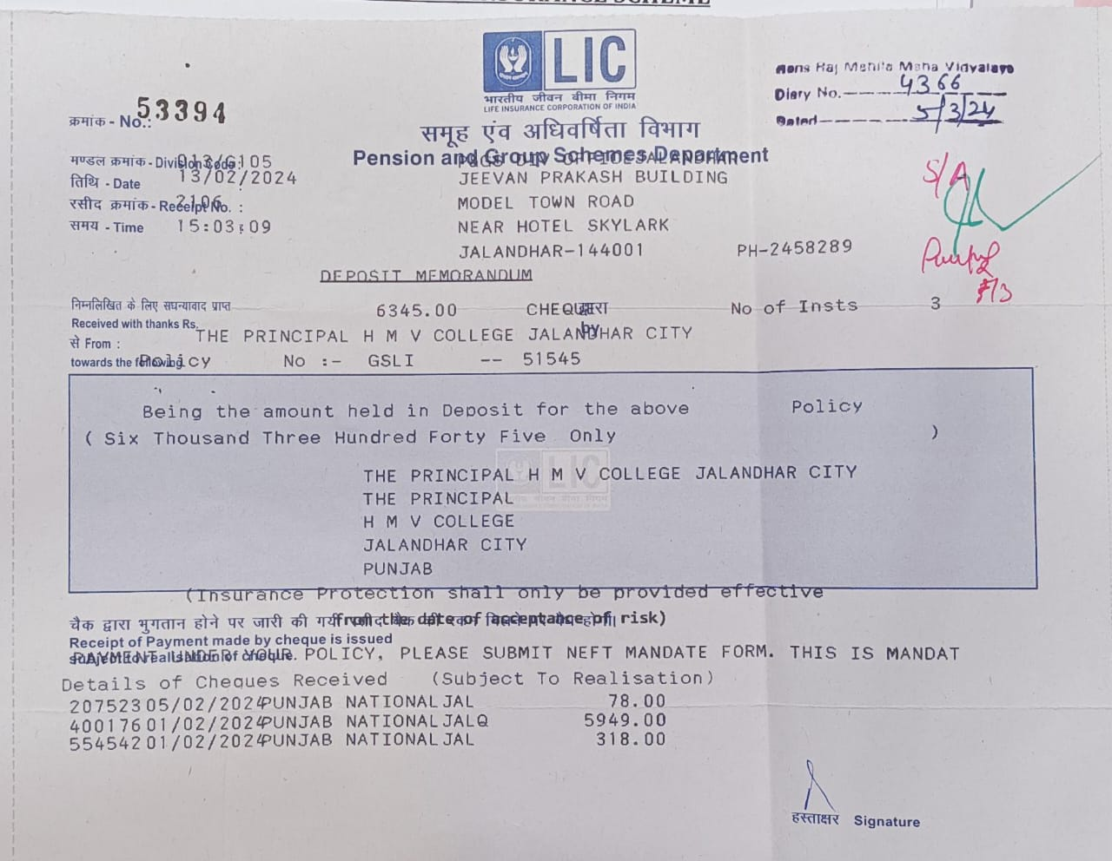

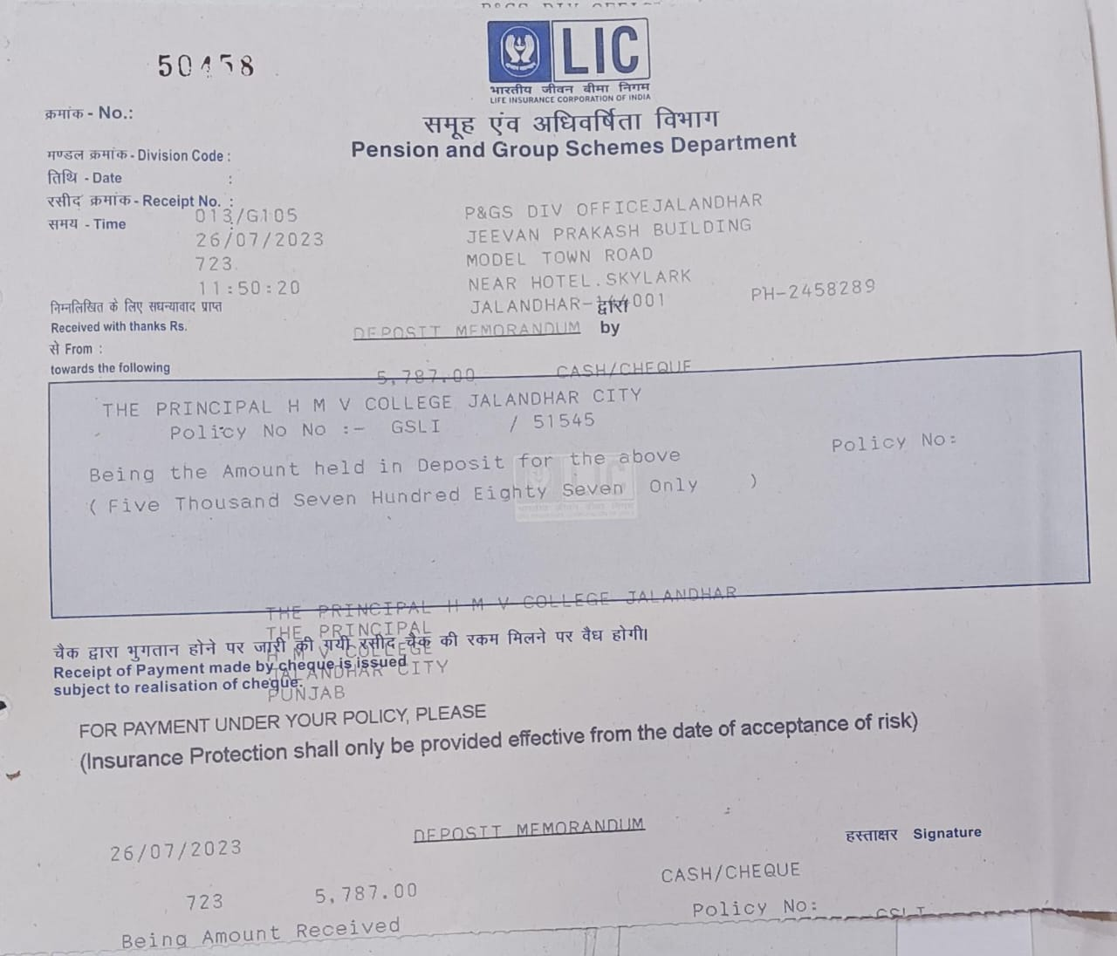
Group Insurance Scheme.
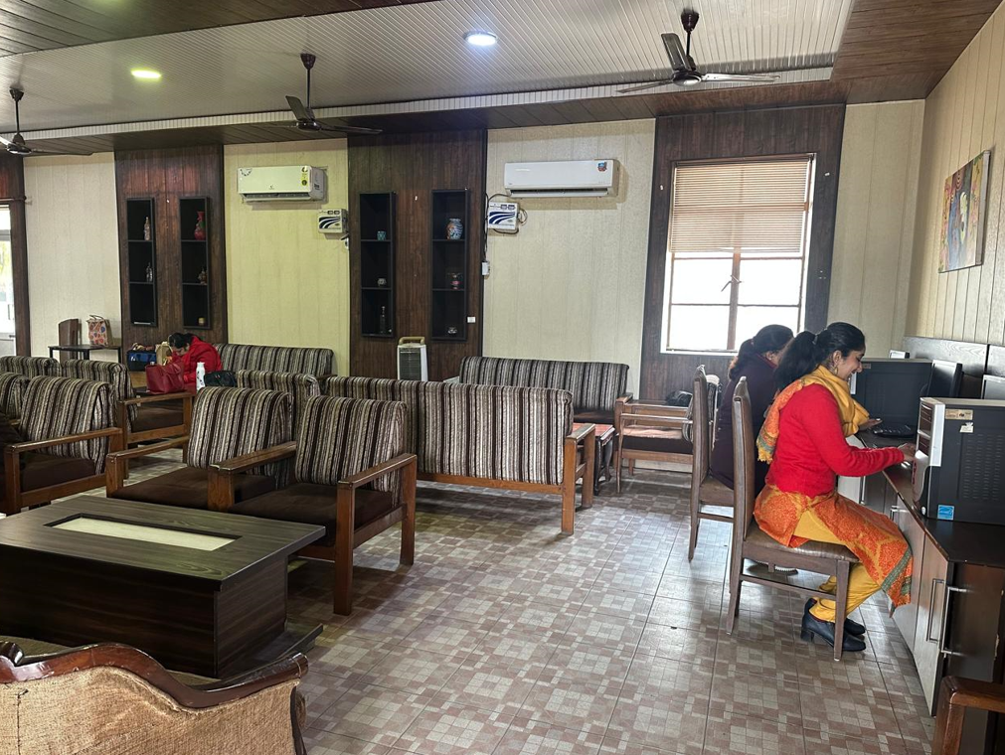
Well-equipped and well-furnished staff rooms with modern amenities.

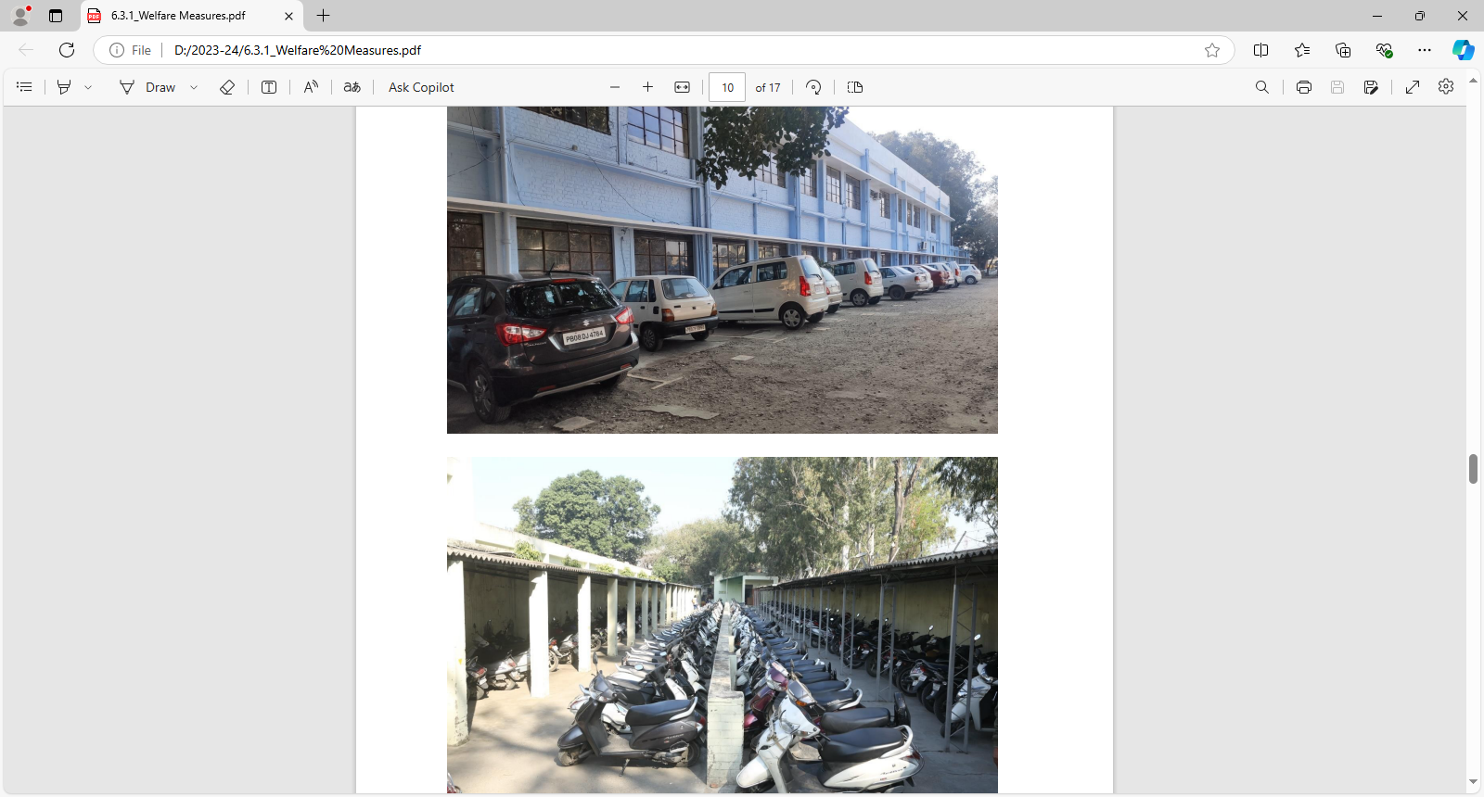
Free parking facility for two wheelers and cars.

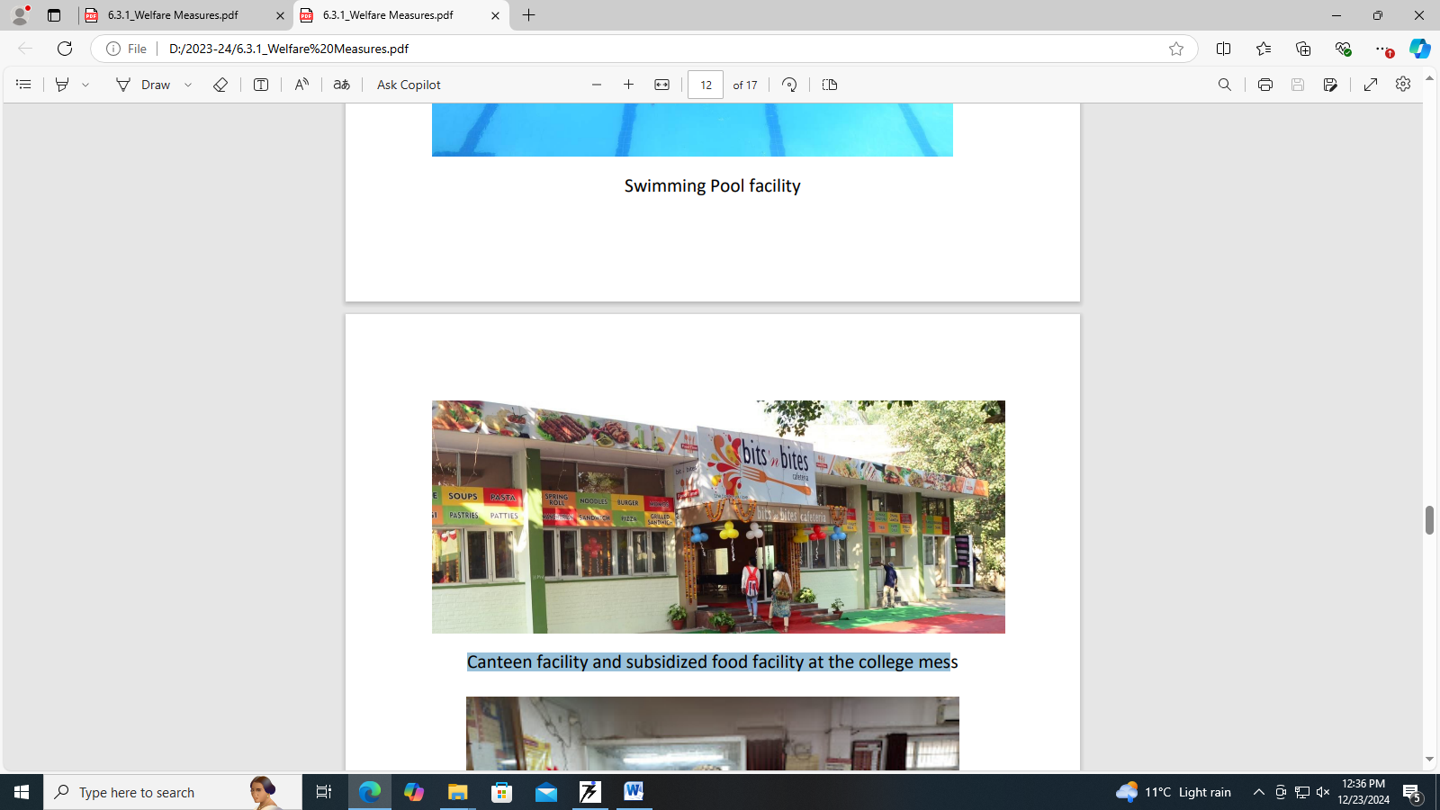
Canteen facility and subsidized food facility at the college mess.

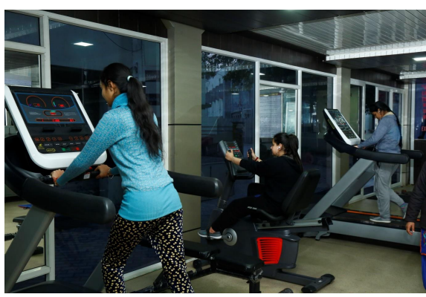
Fitness Zone Gym and Workout station .

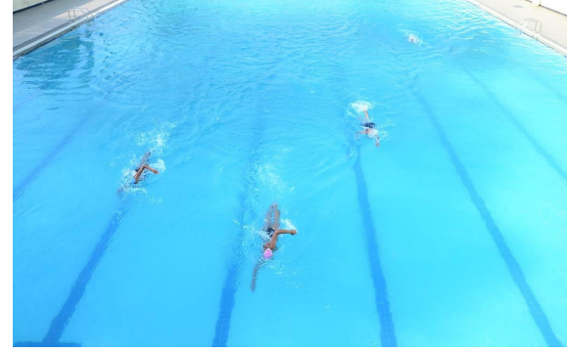
Swimming Pool facility.

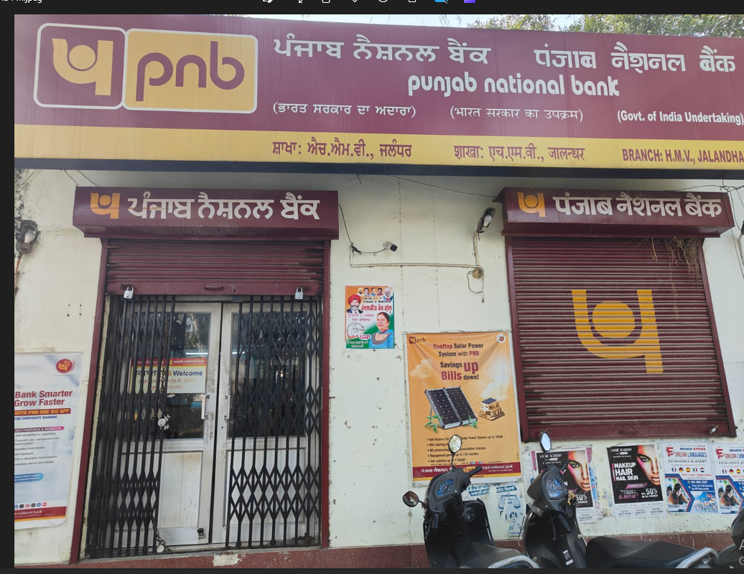
Punjab National Bank branch with locker facility.

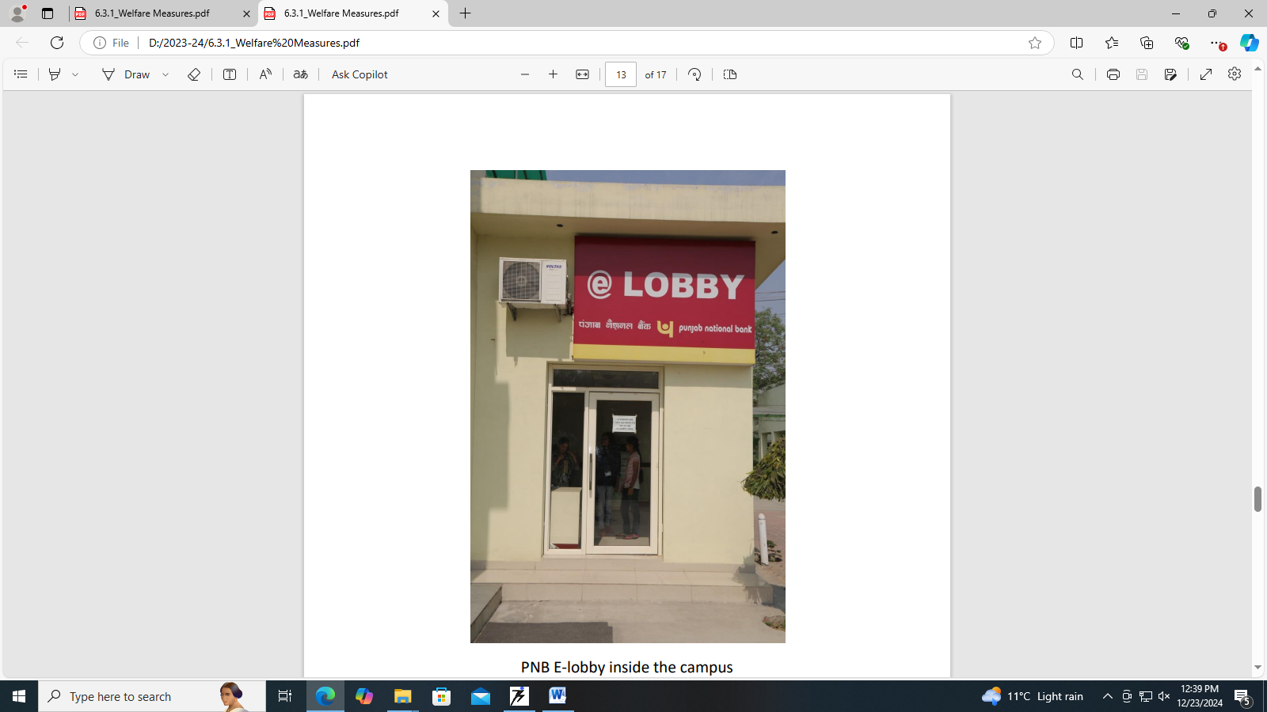
PNB E-lobby inside the campus.
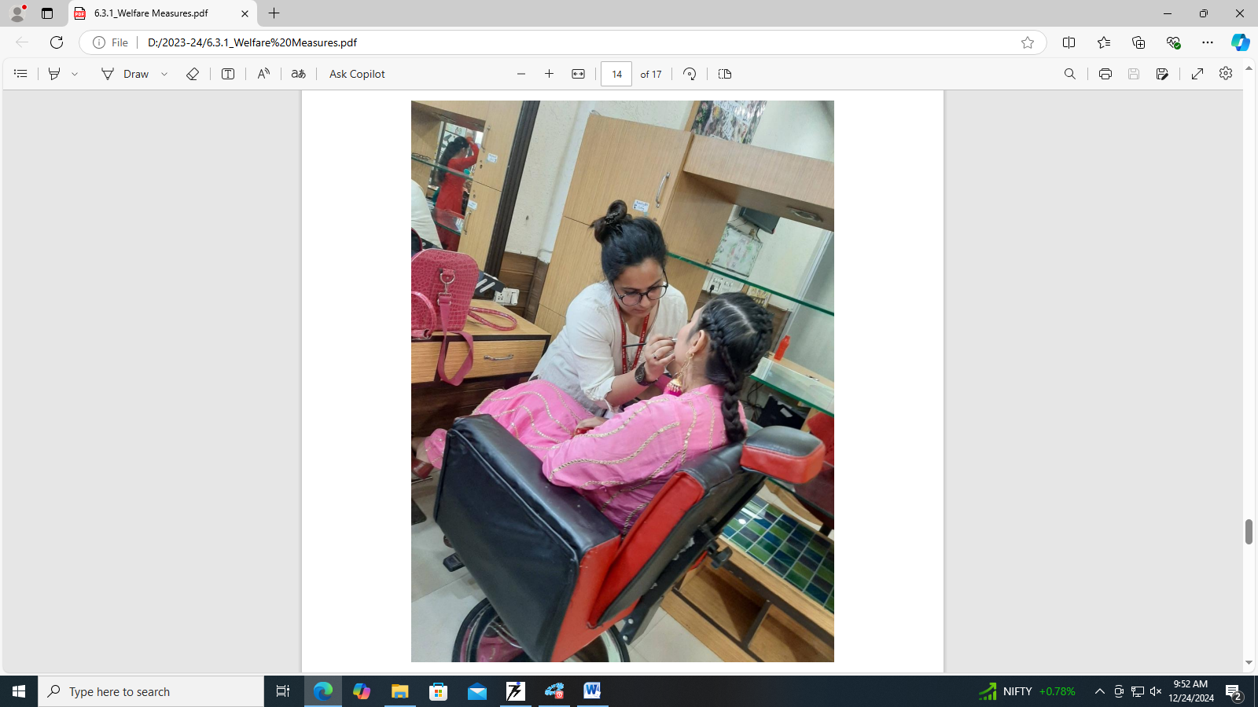
Beauty & Wellness services at the subsidized rates.

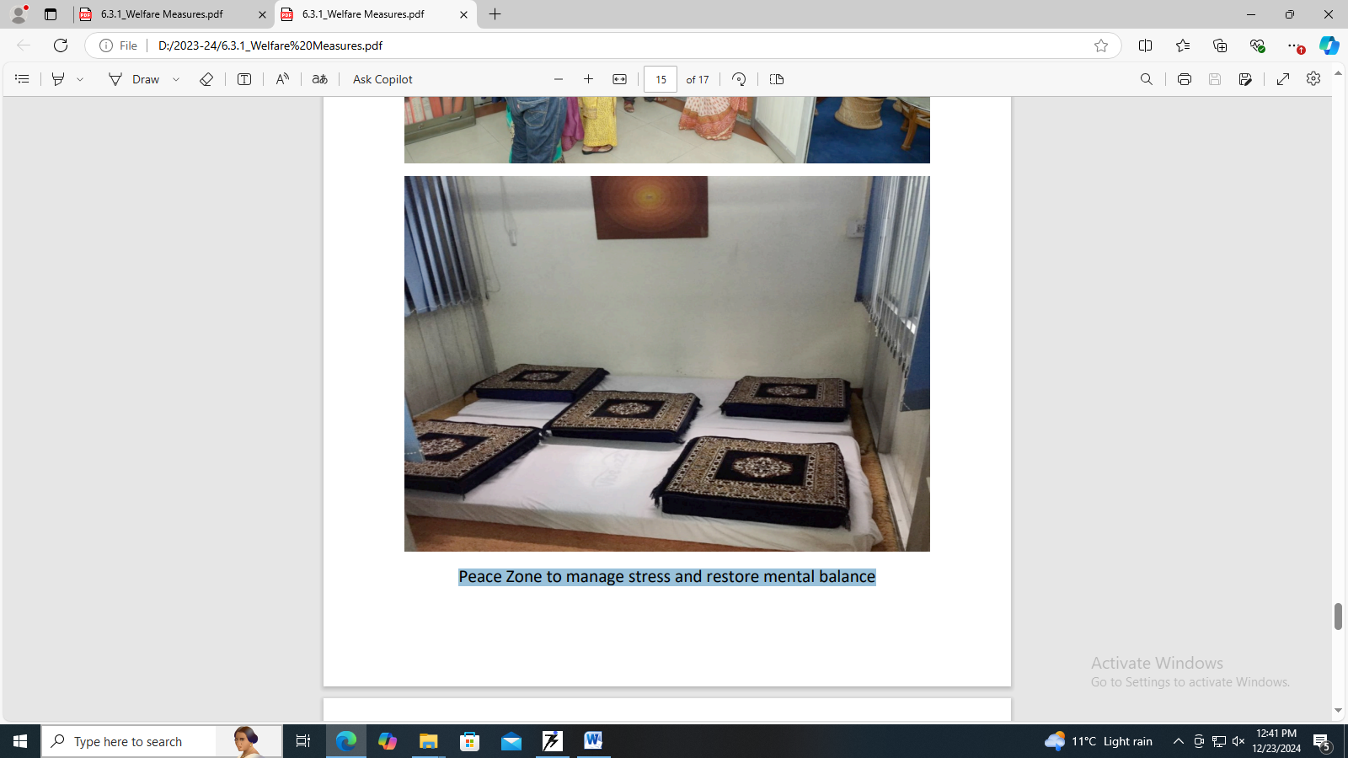
Peace Zone to manage stress and restore mental balance.

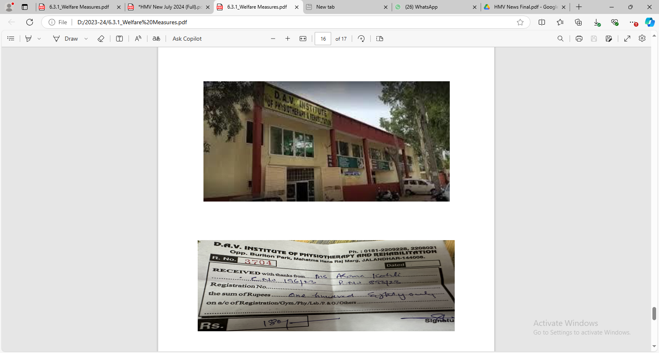
Medical facility at DAV Physiotherapy centre at subsidized rates

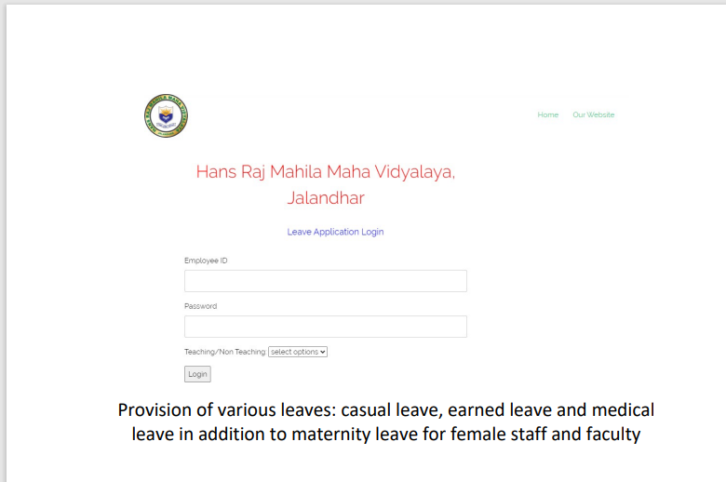
Provision of various leaves: casual leave, earned leave and medical leave in addition to maternity leave for female staff and faculty.

